**Study of Socio-Demographics of ESG investors in India**



Punjab Engineering College

Submitted by:

Rahul Singh :- 23102007

Harshil Mathur :- 23102060

Krish Jain :- 23102078

Contents

1. Abstract…………………………………………………………………………3
2. Introduction…………………………………………………………………….3
3. Objectives………………………………………………………………………5
4. Literature Review………………………………………………………...……5
5. Research Gap…………………………………………………………………..8
6. ResearchDesign….………………………………………………………..…..9
7. Research Methodology………………………………………………………...9
8. Survey Data Analysis and Interpretation……………………………………...10
9. Secondary DataAnalysis……………………………………………………..20
10. Findings………………………………………………………………………23
11. Recommendations…………………………………………………………….24
12. Implications…………………………………………………………………..24
13. Limitations of The Study……………………………………………………..25
14. Conclusion……………………………………………………………………26
15. Bibliography……………………………………………………………………………..27

# ABSTRACT:

This paper investigates the socio-demographic factors that influence individual decisions to invest in Environmental, Social, and Governance (ESG) mutual funds. ESG investors are generally highly educated, having numerical skills and financial literacy and they prioritize sustainability and governance factors that evaluate a company’s alignment with sustainability. Using data collected through surveys we analyze attributes such as age, gender, income, education, geographic location and marital status to identify trends and characteristics common among ESG investors. Utilizing the survey data, we analyze how age and gender influence investment decisions, preferences for ESG criteria, and overall engagement in sustainable investment practices. The findings show that younger investors are more attracted to Socially Responsible Investing.

Significant gender differences were also noted, but these may not be indicative of any major behavioral differences given that the participation of women in investing is low in India. The findings also indicate that SRI investors tend to have higher incomes.

# INTRODUCTION:

In the past few years, there has been an increase in the popularity of mutual funds known as ESG (Environment, Social, and Governance) funds in India (Dr. Shuchita Singh, Dr. Shilpa Bahl, Dr. Jaideep Sharma, Anita Sharma, 2023). Such funds enable the investors to invest their money in those companies which fulfill certain criteria of ecological sustainability, social responsibility, and governance. The growing popularity of these funds indicates a larger trend in the investment world where maximization of profits is not the only point of concern but ethical and sustainable factors are on the table as well. This shift has been especially influenced by the rising awareness of climate issue, social justice and corporate justice.

ESG fund investors in other countries like Portugal have been known to show certain demographic characteristics (Paulo Pereira Da Silva, Victor Mendes, 2021). Age comes into play when it comes to the investment choices made. In most cases younger investors are more attracted towards ESG Investments. These investors find the importance of such practices as climate change and social justice and even putting them in their put away finances.

Older investors, however, seem to be less attracted to them as compared to younger investors. Only a few of the investors from the older generations are aware of ESG funds and are likely to invest in them.

Gender is another key factor that shapes ESG investing patterns. Research indicates that men are more likely than women to invest in ESG mutual funds (Paulo Pereira Da Silva, Victor Mendes, 2021, 2021; Yanuar Triswati, Noer A. Achsani, Roy Sembel, Trias Andati, 2023). This doesn’t necessarily indicate investing attitudes, as not many women in India participate in mutual fund investing (AMFI and CRISIL Research, 2023).

Education and financial literacy are also important characteristics that distinguish ESG investors from traditional investors. People with higher levels of education are more likely to invest in ESG funds since they often have a better understanding of how non-financial factors like governance and environmental sustainability can influence a company’s long-term success. Additionally, educated investors are more adept at analyzing the potential trade-offs between financial returns and ethical considerations.

Besides, ESG investors often shows a higher level of financial complexity than usual investors. This increased exercise suggests that ESG investors are not only interested in the honorable side of their investment but are also interested to optimize return.

In terms of financial behavior,ESG investor inclines to hold a more varied range of mutual funds compared to conventional investors. They are also more probable to secure in long term investment strategies, reflecting their opinion in eternal value of sustainable companies. This patient, long-term approach disagrees with the more short-term, profit-driven attitude that can portray traditional investing. (Paulo Pereira Da Silva, Victor Mendes, 2021)

ESG mutual funds label a new era in the investment sector as investors progressively align their financial decisions with their honorable values. In contrast to traditional mutual funds, ESG mutual funds assess companies based on their environmental footprint, social responsibility, and management. Thus, while receiving monetary profits, investors invest in companies that perform in regard to ESG goals. The trend is led by the younger generation, motivated toward positive societal change. There are younger investors, and with them are many older investors who believe that well-governed companies would spell long-term stability. So, the future of investing is this: sustainable investment. This is further supported by growing awareness of risks that companies face if they fail to respond to environmental and social issues—the absence of effective regulation or solid reputation measures that could lead to reputational damage or regulatory penalties. Such information increases more informed and value-aligned investment decisions. Growth in ESG mutual funds reflects a fundamental shift in investor attitudes towards financial decision-making. As ESG investing is getting popular and nearly mainstream, it is destined to play a leading role in the future of finance. For most people and institutions, ethical considerations are thus soon going to be integrated into their investment strategy.

**Objectives:**

* **To find the socio-demographic details of ESG mutual fund investors in**

**India.**

* + The study will try to find demographic details like age, gender, education, marital status, geographical location, income etc. of people who invest in ESG centric mutual funds in India.
* **To compare demography of ESG mutual fund investors in India with other countries.**
* The study aims to compare demographic data of ESG investors in India with that of investors in other countries to find factors which are similar in behavior and factors where India differs from the rest of the world.

## Literature Review:

1. **ESG in investor profiling: what are we talking about? (Andrea Lippi, Federica Poli, 2023)**

The paper attempts to explore the socio-demographic characteristics of investors in Italy who invest in ESG. Through a survey on a sample size of 190 respondents, the study looks at how Italian investors prioritize ESG, and the demographics of these investors. The results of the study indicate that factors like age, gender and education have a significant impact on whether investors are inclined towards ESG. Males, investors belonging to younger age groups and those with higher education have a higher tendency to invest in ESG. But financial literacy didn't show any significant relation with ESG preferences.

1. **Investors in ESG Mutual Funds (Paulo Pereira Da Silva, Victor Mendes, 2021)**

The paper analyses data from a Portuguese bank over a period of 20 years to study the demographic data of SRI (Socially Responsible Investing) investors in Portugal, that is, investors who invested in mutual funds with ESG characteristics. The findings of this studied showed that in Portugal, a vast majority (85%) of the SRI investors are male. The study also revealed that Portuguese SRI investors are ofetn younger than normal investors. The study also showed that such investors tend to have a higher level of education and financial literacy than other mutual fund investors. The study also showed that most of the SRI investors in Portugal are concentrated in Lisbon and Porto, which are the largest urban centers of the country.

1. **A comparison of investment behavior, attitudes, and demographics of socially responsible and conventional investors in India (RenuJonwall, Seema Gupta, ShuchiPahuja, 2022)**

The paper aims to study the preferences of investors in India towards SRI (Socially Responsible Investing) in comparison to other traditional investments. This study investigated how SRI investors in India differ from conventional investors in demographics and investing behavior.  
The results of this study showed that SRI investors showed higher levels of awareness towards ESG issues. The findings indicate that such investors are primarily male. The study also shows that these investors are younger than conventional investors and tend to have a higher level of education. These investors also showed significantly higher levels of income.

1. **Characteristics of Mutual Fund Investors (ICI Research - Sarah Holden, Michael Bogdan, Daniel Schrass, 2023)**

This paper analyzes the demography of mutual fund investors in the United States of America. The findings of this study show that a majority of the households in the United States owned mutual funds. This study found that most of the ownership of mutual funds is with people of working age. The study also revealed that most investors are employed and show a moderate to high level of income according to United States standards. The study also showed that most investors held mutual funds for retirement saving. The study also revealed that equity mutual funds are the most commonly held mutual funds and that most investors wish to hold mutual funds for a longer term.

# A study of behaviour of mutual fund investor in India (Geetika Tandon Kapoor, 2022)

The paper analyzes the interconnection between investor behavior and demographic aspect in Uttar Pradesh. Paper uses data from 200 respondents. Analysis of the gender, education, marital status and income of the respondents has been done to establish relationship with investment preference in mutual funds. Results shows that males and married individuals tend to invest more. Conventional investment options like cash and LIC are favored over mutual funds. The study encourages the mutual funds investment in India.

1. **Investment decision in Indonesia Stock Exchange: The demographic of environmental social, and governance investor (Yanuar Triswati, Noer A. Achsani, Roy Sembel, TriasAndati, 2023)**

The paper aims to study the factor affecting the investment decision in Indonesia, mainly focusing on significance of ESG consideration. It traverses how ESG criteria (environmental responsibility, social impact and governance practices) impacts investment choices, especially for investors pledged to the sustainability and moral investment. The document likely reviews habit, challenges and opportunities in the Indonesian market from the viewpoint of investors who prioritize ESG framework.

1. **Performance Evaluation of ESG Mutual Funds in India (Dr. Shuchita Singh, Dr. Shilpa Bahl, Dr. Jaideep Sharma, Anita Sharma, 2023)**

The paper made an attempt to analyze ESG based mutual funds in India. This paper compares the returns of ESG funds with other regular (non-based) and for that it uses secondary data, as two different types of financial ratios, Sharpe and Sortino. According to the report, ESG funds has risen from only one in 2006 to ten at present. It has found that ESG mutual funds have performed in line with conventional mutual funds, and them outperformed at certain points of time. The report also highlighted that there remains a lack of data, given how young most ESG funds are.

### Emerging paradigms in socially responsible investment (SRI)—A study with focus on ESG mutual funds in India (M. Vishali, Muhammed Shafi,2023)

### Socially Responsible Investment in India have greatly involved the use of Environmental, Social, and Governance, or ESG, factors in investment decisions. SRI focus on aligning investments with ethical principles such as sustainability and social responsibility while seeking a return. Although SRI in India have been growing there are still several challenges in it including a lack of customer awareness about the strategy and importance regarding ESG. Also strict ESG parameters limit the choices for investment and ESG-monitoring costs higher than the usual. Long-term financial performance and risk management efficiency are expected to assure further investment as more companies embrace ESG-friendly policies

### ESG Investing: Theory, Evidence, and Fiduciary Principles (y Max M. Schanzenbach, Robert H. Sitkof,2020)

### This article cuts through that confusion to provide guidance about when and how ESG investing by trustees and investment fiduciaries is permissible. It provides a clear taxonomy on the meaning of ESG investing, differentiating between risk-return ESG (i.e. using ESG factors to improve risk-adjusted returns) and collateral benefits ESG (i.e. using ESG factors for third-party effects). The study discusses the subjectivity inherent to identifying and applying ESG factors, which complicates assessment of ESG investing strategies. It summarizes the current theories and evidence on whether ESG investing can improve risk-adjusted returns, finding the results to be mixed and contextual;

### Growth and Performance Measurement of ESG-themed Mutual Funds in India: An Empirical Investigation (Shikha Gupta, 2022)

### This study aims to analyze the growth of ESG mutual funds in India and evaluate their performance using standalone return and risk measures as well as widely recognized risk-adjusted measures, namely, Sharpe Index, Sortino Measure, and Jensen’s Alpha. With respect to growth, the study found that the industry is still in its infancy though a steady and positive momentum is seen both in terms of number as well as assets under their management. The findings of the study substantiate that ESG investing not only leads to the accomplishment of sustainability goals of investors but also affords them returns higher than the traditional route to investing.

## Research Gap:

Over the course of the last few years, the popularity of ESG based mutual funds has grown significantly in India. This is testament to desire among investors to invest in assets which are socially responsible. Even though the prevalence of ESG funds has increased greatly in India, there is a lack of studies on the demography of ESG investors. A vast majority of the existing studies on ESG funds analyze the integration and performance of these funds in comparison to conventional funds.

There exist a few studies that look at the demography of ESG fund investors, but most of these studies are done on populations of countries other than India. This lack of understanding of Indian ESG investors' age, education, gender et cetera leaves crucial data unavailable.

Exploring the demographic features of these investors is crucial. It can help policymakers and financial institutions curate their strategies better and promote ESG investing, which is crucial for a better and sustainable future.

# Research Design:

# This research paper employed mix methods to find the demographic details of Indian ESG investors and compare them with data available for other countries. The intention was to find similar patterns and points of contrast between India and other countries.

# Variables under study:

# Age: The paper aims to establish the relationship between age and preference towards ESG based funds.

# Gender: The study aims to find correlation between the gender of the investor and attitude towards ESG investing.

# Income: The study aims to analyze the relationship between income and attitude towards ESG investing.

# Geographical Location: The study aims to establish a correlation between geographical location and preference towards ESG based funds.

# Educational Qualification: The study aims to establish the relationship between educational qualification and attitude towards ESG investing.

# Research Methodology:

# The paper employs mixed methods to achieve its objectives.

# Literature review: A detailed review of several existing pieces of literature was conducted, using papers published in the last three years. The literature review was used to gather secondary data and identify research gaps to work on.

# Survey: A structured survey was conducted to gather the required primary data. The survey used responses from investors to gather data such as age, gender, education, income, occupation etc. The survey recorded 84 responses, which provided sufficient data for analysis.

# Statistical Analysis: Using the data collected from the survey, the mean, median, frequency distribution and other statistical information was found.

# Comparative Analysis: The findings of this study were compared with other studies, especially those done in other countries to find various points of similarities and contrast.

**Survey Analysis:**

### The survey consisted of a structured questionnaire to help collect the required data. The responses are hereby presented in the forms of graphs and charts to help understand the data in a simple manner.

**Q1) What is your age?**

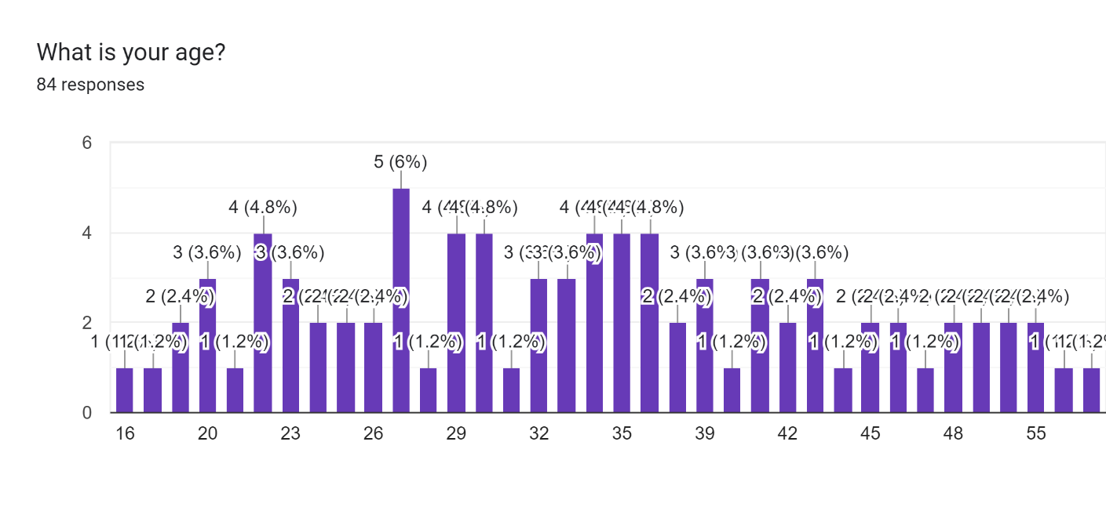

From the survey, we observe that the most of the ESG investors lie in the 18–40 year-old age group, with a mean age of 34 years. This indicates that younger people have a higher tendency to invest in socially responsible assets. A possible reason for this is that younger people tend to be more aware of and be more sensitive towards ESG issues.

**Q2) What is your marital status?**



The survey found that a vast majority of the investors were married individuals.

**Q3) What is your gender?**

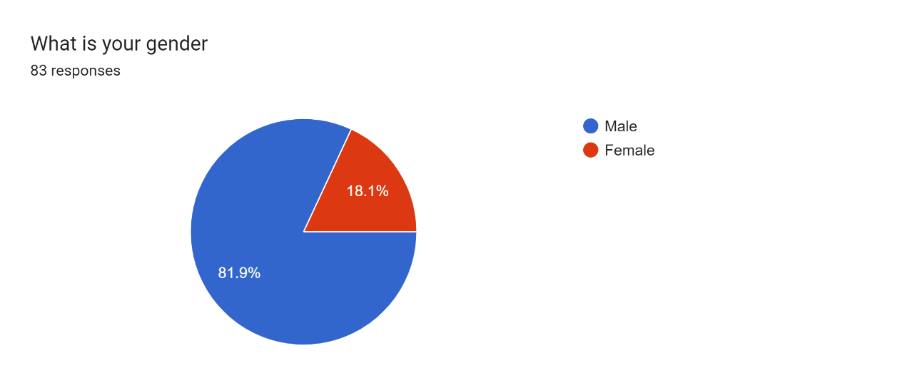

While the survey showed that an overwhelming majority of the ESG investors are male, this may not represent a true picture of the awareness towards ESG issues. A plausible explanation for this is the fact that most investors in India are male, whether conventional or ESG. Share of women in the Indian mutual fund industry is only about 20%. (AMFI and CRISIL research, 2024)

**Q4) Do you know about ESG mutual funds?**

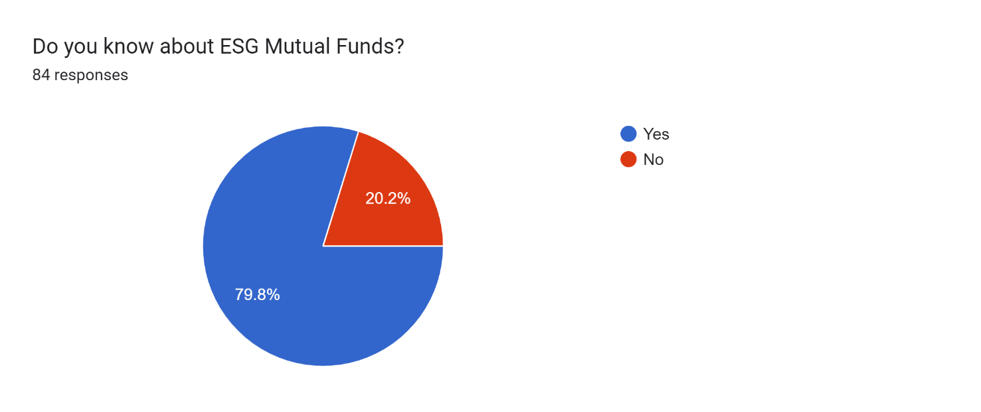The survey indicated a high level of awareness towards ESG mutual funds. Given that most of the respondents were young, this shows that there is a high level of awareness towards ESG mutual funds in India, especially among younger investors.

### Q5) In which region of India do you live?

### Forms response chart. Question title: In which region of India do you live?. Number of responses: 84 responses.

### The survey indicated that a majority of the respondents lived in North India. This may not be truly indicative of the relationship between the geographical region and the tendency to invest in ESG based mutual funds, because of the nature of the population which took the survey.

### Q6) Which state do you live in?

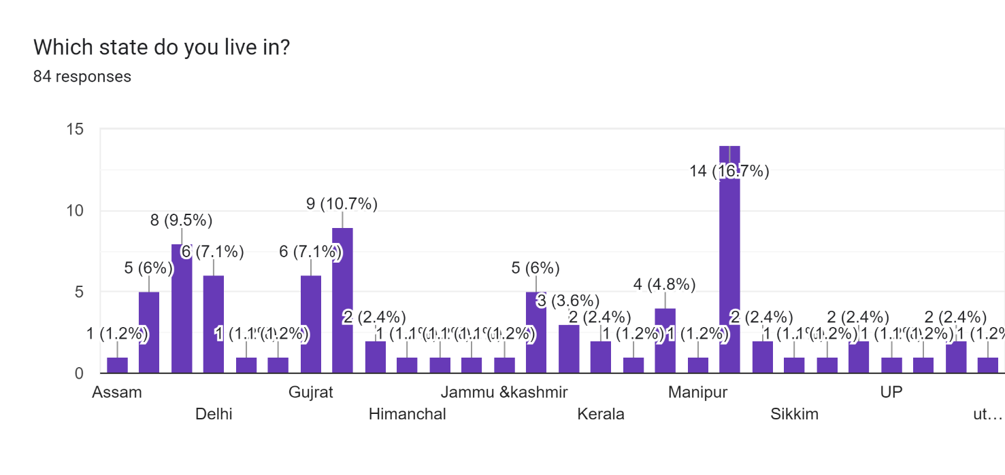Most of the respondents of this survey were residents of the northern states of Punjab, Haryana and the union territory of Chandigarh. A sizeable portion of the respondents were also from western and southern India. Again, due to the nature of the population which took this survey, this may not be a true indicator of relationship between geographical location and attitude towards ESG based funds.

**Q7) Do you live in urban or rural areas?**

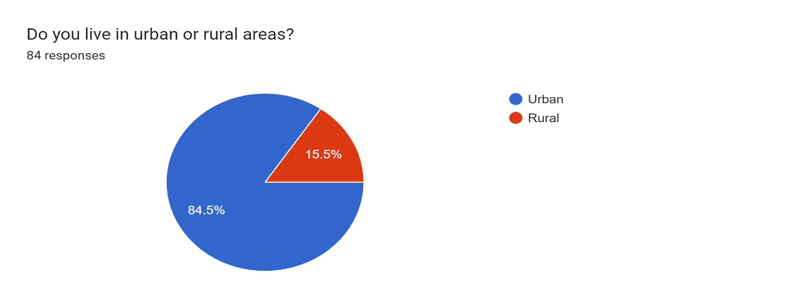

The results of the survey indicate that most of the ESG fund investors in India are based

in urban areas. This is because people urban areas usually have more awareness and

education about ESG issues. Urban people also tend to have higher income than rural people, nearly twice as much (Government of India,2023), along with more avenues to invest their money in.

**Q8 What is your annual income?**

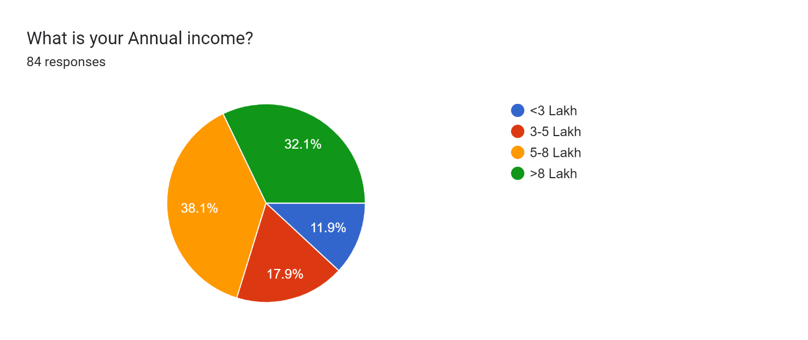

The income of the majority of the respondents exceeded 5 lakhs, with the mean of the income being more than 6 lakhs. This number is significantly higher than the per capita income in India, which indicates that people who invest tend to have higher income than others.

**Q9) What is your educational qualification?**

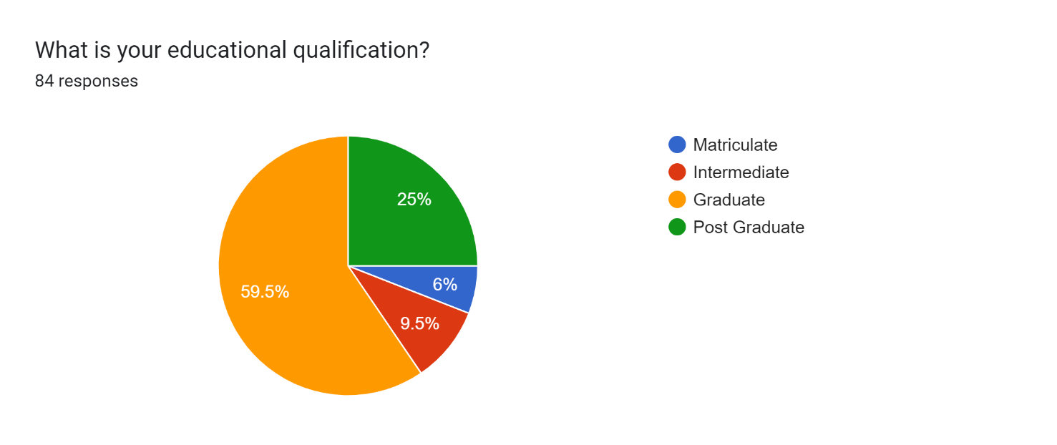

According to the survey the majority (59.5%) of the investors which filled the google form were graduate and the least qualification be matriculate (6%). A vast majority of the respondents held at least one university degree. This indicates that ESG investors tend to possess a higher level of education as compared to the average person in India, where the majority of people are not graduates. (Census data)

**Q10) On a scale of 1-5, how important is the ESG rating of a mutual funds for you to invest? 1 being the lowest and 5 being the highest.**

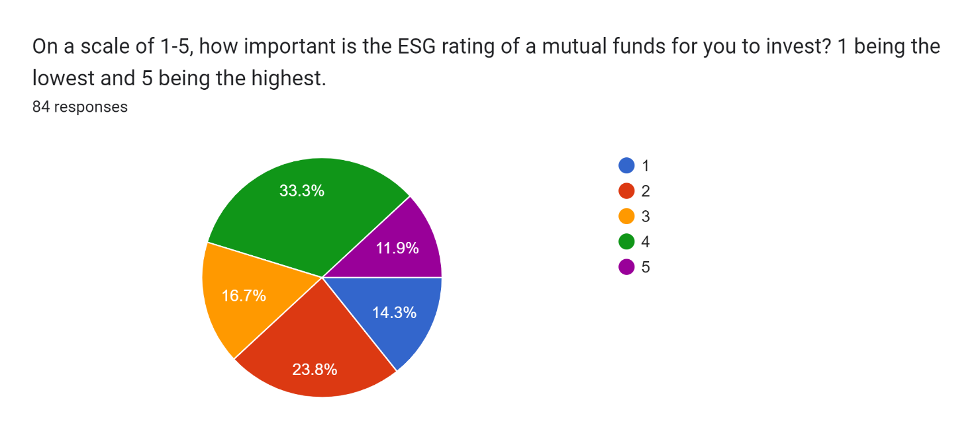

A majority of the respondents gave a high importance to the ESG rating of a mutual fund. This indicates that the investors are not only aware of the various ESG issues present, they also show a tendency to be mindful of them and show a desire to invest in socially responsible assets.

**Q11) How likely are you to invest in an ESG based mutual fund?**

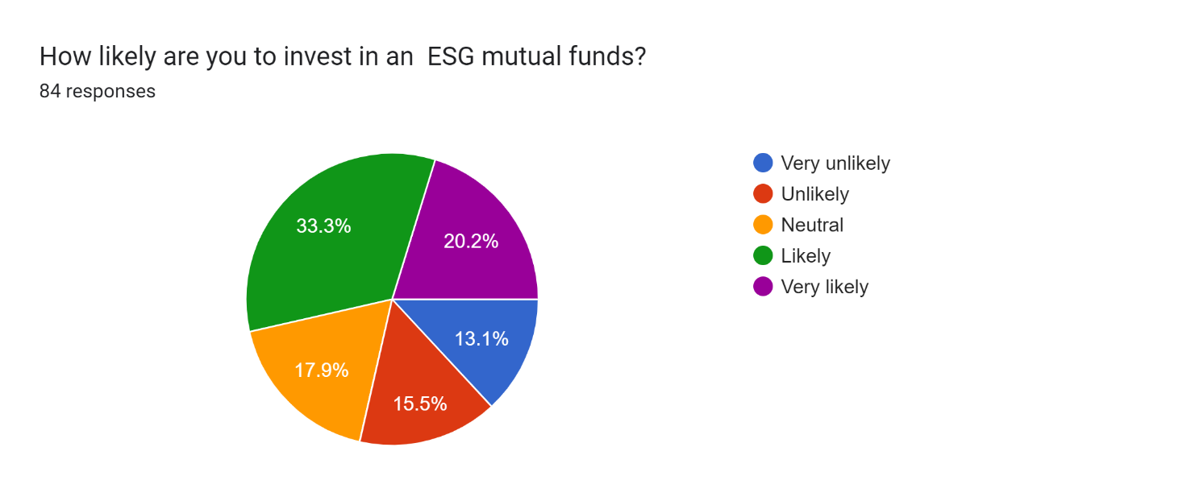

The survey showed that a majority of the respondents were likely to invest in ESG based mutual funds. This was especially prominent among younger investors. This indicates that investors don’t only want to maximize their profits, rather they want to do it in a socially responsible way.

**Q12) What is your occupation?**

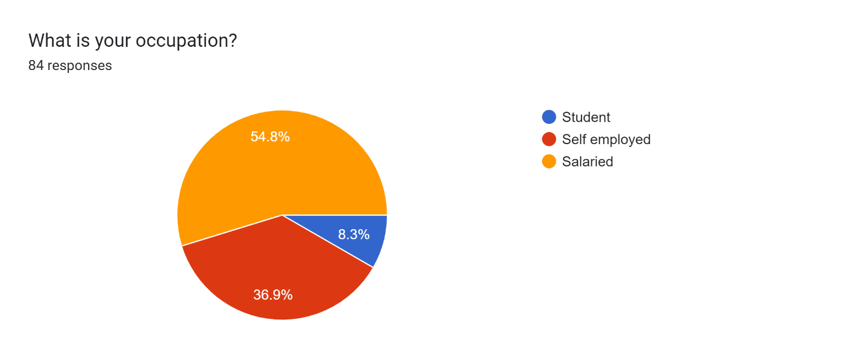

The survey found that most of the investors were salaried employees. A significant number of investors were also self-employed. The survey indicated that the prevalence of investing among students is quite low. The survey also showed that self-employed people invested more money in mutual funds, but it does not show any recognizable pattern for ESG investments. It simply indicates that self-employed people tend to invest more.

### Q13) Would you be willing to accept a lower rate of return for an ESG mutual funds?

84 responses

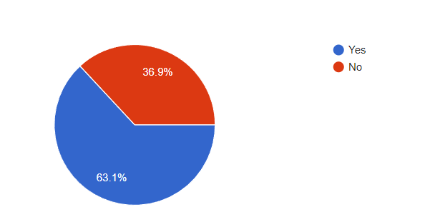

The data shows that the majority survey size reposes yes for accepting the lower rate of return for investing in ESG centric mutual funds but this should not be considered as an absolute picture. The average age of the survey size is young so this data may indicate that in young people the probability of accepting a lower rate of return for investing in ESG centric mutual funds is very high, around 60% to 65%. This is a great indicator for the growth of the ESG mutual fund investments.

### Q14 If yes, what margin of return less than normal would you accept for an ESG centric mutual fund.

60 responses

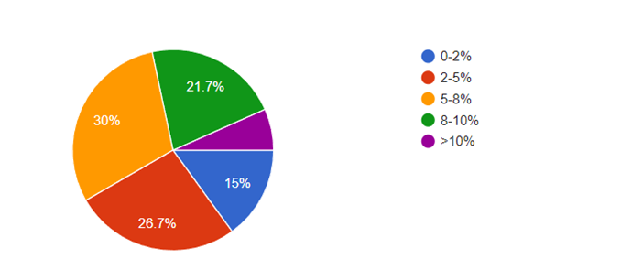

Investors are willing to accept a reduced return for ESG-centric funds, but the extent of the reduction varies. Most responses likely indicate moderate reductions (e.g., 0-8%) are more acceptable, with fewer respondents willing to accept larger reductions (e.g., 8-10% or higher). This is when the average age of survey size is young the trend is observed that the older investors are not willing to accept lower return for a ESG centric mutual fund. This shows that while investors, especially younger investors, are willing to let go of a fraction of the return for an ESG based fund, the margin is still on the lower side.

**SECONDARY DATA ANALYSIS:**

Here we compare our findings with data available from other studies to find any similarities and differences, along with any recognizable patterns that can be observed.

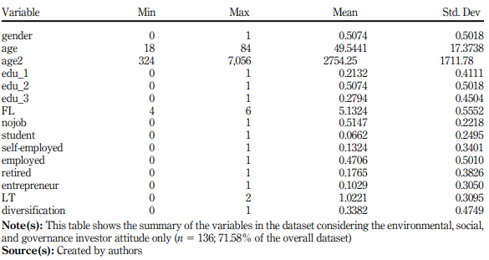

Demographic data for Italy

Source: Andrea Lippi, Federica Poli, 2023

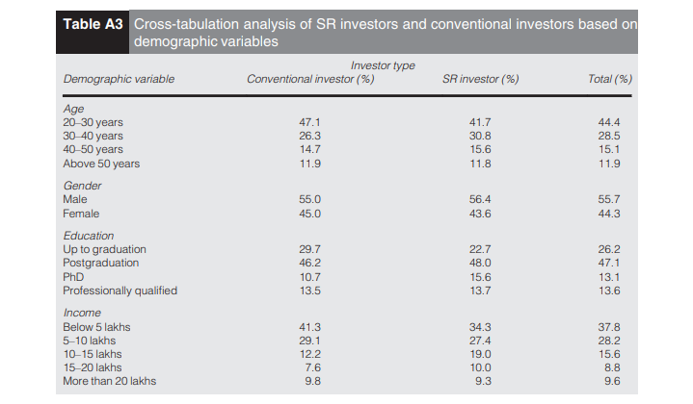

Demographic data for India

Source: Renu Jonwall, Seema Gupta, Shuchi Pahuja, 2022

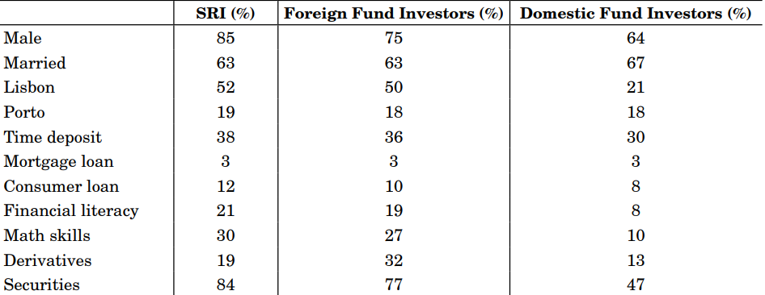

Demographic data for Portugal

Source: Paulo Pereira Da Silva, Victor Mendes, 2021

### Demographic comparison between Portugal & Italy &India

|  | India | Portugal | Italy | Indonesia |
| --- | --- | --- | --- | --- |
| Gender (Male) | 80% | 85% | 50.74% | 64% |
| Age (in years) | 34.2 | 55.4 | 49.5 | 39 |
| Marital Status (Married) | 69% | 63% | - | - |
| Urban | 84% | >71% | - | - |
| Self Employed | 37% | 31% | 23% | 30% |
| Salaried | 55% | 63% | 47% | 68% |
| Above graduate level education | 84.5% | 72.1% | 77% | 87% |

Sources - (i) Portugal - (Paulo Pereira Da Silva, Victor Mendes, 2021) (ii) Italy - (Andrea Lippi, Federica Poli, 2023) (iii) Indonesia - (Yanuar Triswati, Noer A. Achsani, Roy Sembel, Trias Andati, 2023)

The above table presents a comparison of this paper’s findings with the data published for Portugal, Italy and Indonesia.

The participation of women in ESG investing is significantly higher in Italy as compared to India, Indonesia and Portugal. This shows that India lags severely in participation of women in mutual fund investing. Other research also points to the same thing, that the participation of women in investing in India is quite low. (AMFI and CRISIL research, 2024)

Indian ESG investors also differ significantly from their Portuguese and Italian counterparts in terms of age. The age of both Italian and Portuguese ESG investors tends to be around 50, while according to this survey, it is around 34 for India. India exhibits similar age as compared to Indonesia. A possible explanation for this is the fact that a significant proportion of the population of both Indonesia and India is youth (Census data). But what needs to be kept in mind is that while the Italian and Portuguese ESG investors are clearly much older than Indians and Indonesians, they also follow the same trend of being younger than conventional investors.

The other demographics follow similar trends for all the four countries. A majority of ESG investors are married, salaried and possess a high level of education.

# FINDINGS:

# Upon the analysis of the available primary and secondary data, the study was able to determine the characteristics of ESG investors in India.

# The study found that ESG investors in India tend to be younger people, with a mean age of 34 years. They also tend to be married individuals and males. It was observed that most of the ESG investors were based in urban areas. The findings showed that most of the investors were willing to let go of some of the return they could have earned by investing in a conventional mutual fund if it meant that they invest in a socially responsible mutual fund.

# The findings of this study also closely resemble the results of a similar study in India done by Renu Jonwall, Seema Gupta and Shuchi Pahuja in 2022 with similar results for almost all demographic variables except for gender, which despite being lower than our findings, still points to majority of socially responsible investors being male.

# On comparison with secondary data available for countries like Portugal, Italy and Indonesia, several similarities and differences were observed.

# The data for all four countries showed that males comprised the majority of mutual fund investors, though Italy showed a considerable difference from the other three, in that males exceeded females by only a small margin.

# In all four countries, ESG investors were found to be younger than conventional investors and were found to possess a higher level of education and income.

# RECOMMENDATIONS:

Based on our findings, we recommend these steps to be taken:

1. Steps should be taken to enhance the awareness about ESG funds in India. While the urban population is quite aware of ESG investing, there needs to be more awareness developed among the rural people.
2. The share of women investors, in both ESG and conventional mutual funds, must be increased. Since the present share of women investors is about 20%, a large chunk of the Indian population has no representation in the mutual fund industry.
3. Policies need to be made to promote ESG investments among investors, such as tax benefits and grants for companies that perform high on ESG standards, and on investor earnings through ESG investments, so that the market can be made more ESG centric, helping build a more sustainable and equitable future.
4. Areas where India lags other countries need to be identified and worked upon to bring India on par with the rest of the world.
5. There should be further study research on related topics like motivations behind ESG investing to better understand ESG investing and help formulate better policies and strategies to help pave a way for sustainable growth.

**IMPLICATIONS:**

# The implications of this study can be quite vast.

# The knowledge of the demographics of ESG investors can help financial entities create strategies tailor made for their target audience, helping them increase their popularity and earnings.

# The findings of this study can be used to understand the target demographics to be educated about ESG investments, which can help further increase the popularity of ESG investments and can help move towards a sustainable future.

# The results of this study can help in making policies conducive to promotion of ESG investing to start a more widespread shift to Socially Responsible Investing, helping in moving towards a better world, where ESG issues are better understood.

# The understanding of demographics of ESG investors can help analysts better predict future trends, which can help in guiding investments, leading to more wealth generated for Indian investors.

# The findings of this study show a growing interest in ESG investing. This can make companies move towards better management and more sustainable methods in search of better profits. This can in turn increase investor wealth while moving the world to a much more sustainable future.

# The comparison with other countries can help identify universal trends which can help understand ESG investing globally.

# The comparison with other countries can also help areas where India lags behind, and areas where further work is needed.

# LIMITATIONSOFTHESTUDY:

* **Insufficient Primary Data:** Our source of primary data was a google form. The form had only 84 respondents, which resulted in a lack of enough data. Given that the sample size was not large enough, any trends in the data may have been exaggerated a bit.
* **Biases due to nature of survey participants:** The google form was not open in nature, rather it was filled by some select individuals. Due to this, some factors like geographical location may show a significant bias and may not represent the true nature of all ESG investors.
* **Insufficient secondary data:** Since the demography of ESG investors in India has been a relatively untouched topic, there was a lack of secondary data to compare and contrast our findings with.

# CONCLUSION:

# ESG centric mutual funds are a growing market in India. ESG funds represent a new era of investing where the investors don’t only want to make profits, but want to do through socially responsible methods.

# The popularity of ESG mutual funds has grown significantly in India over the past few years, representing the shift in investor attitudes. Investors, especially young, highly educated and urban investors, are now more attracted to ESG centric funds.

# This is not only significant for ESG goals, but also financial goals as the performance of ESG centric funds in India has been on par with conventional funds.

# With the competitive performance of ESG centric mutual funds, a further increase in their popularity can be expected. This provides a great opportunity for financial institutions to make relevant strategies and policies, giving investors and companies a chance to increase profits while doing it in a sustainable and equitable way.

# BIBLIOGRAPHY:

**1. ESG in investor profiling: what are we talking about? (Andrea Lippi, Federica Poli, 2023)**

**2. Investors in ESG Mutual Funds (Paulo Pereira Da Silva, Victor Mendes, 2021)**

**3. A comparison of investment behavior, attitudes, and demographics of socially responsible and conventional investors in India (Renu Jonwall, Seema Gupta, Shuchi Pahuja, 2022)**

**4. Characteristics of Mutual Fund Investors (ICI Research - Sarah Holden, Michael Bogdan, Daniel Schrass, 2023)**

### 5. A study of behaviour of mutual fund investor in India (Geetika Tandon Kapoor, 2022)

### 6. Investment decision in Indonesia Stock Exchange: The demographic of environmental social, and governance investor (Yanuar Triswati, Noer A. Achsani, Roy Sembel, Trias Andati, 2023)

**7.Performance Evaluation of ESG Mutual Funds in India (Dr. Shuchita Singh, Dr. Shilpa Bahl, Dr. Jaideep Sharma, Anita Sharma, 2023)**

### 8.Emerging paradigms in socially responsible investment (SRI)—A study with focus on ESG mutual funds in India (M. Vishali, Muhammed Shafi,2023)

### 9. ESG Investing: Theory, Evidence, and Fiduciary Principles (Max M. Schanzenbach, Robert H. Sitkof,2020)

### 10.Growth and Performance Measurement of ESG-themed Mutual Funds in India: An Empirical Investigation (Shikha Gupta,2022)

### 11. <https://www.thehindu.com/news/national/Only-8.15-of-Indians-are-graduates-Census-data-show/article60334841.ece#:~:text=Over%20the%20weekend%2C%20the%20office,six%20times%20as%20many%20illiterates>.

### 12. https://www.amfiindia.com/Themes/Theme1/downloads/AMFI_womensDay